Triple Offset Metal-Seated Butterfly Valve Manual
The triple offset metal-seated butterfly valve series is our company's flagship product, widely applied in metallurgy, light industry, power, petrochemical, and city gas / water pipeline sectors.
1. Features and Applications
This valve employs a triple offset metal sealing structure, providing excellent sealing performance at both room temperature and high temperature. Compared to gate valves or globe valves of the same规格, it offers smaller volume, lighter weight, flexible opening/closing, and longer service life. It is widely suitable for metallurgy, light industry, power, petrochemical, and city gas/water pipeline sectors. Safe and reliable in operation, it represents the ideal choice for modern enterprises.
2. Standards
D343H-16C/25 D373H-16C/25 -- conform to the following standards:
1. Design, manufacture, and inspection per JB/T8527-1997.
2. Flange connection dimensions per GB9113.3-88 and GB9113.4-88.
3. Face-to-face length per GB12221-89.
4. Valve pressure testing per GB/T13927-92.
D343H-150Lb D373H-150Lb -- conform to the following standards:
1. Design, manufacture, and inspection per API 609.
2. Flange connection dimensions per API 609.
3. Face-to-face length per API 609.
4. Valve pressure testing per API 598.
3. Main Performance Specifications -- See Table 1
Table 1 Main Performance Specifications
Nominal Pressure PN | GB1048 |  |  | ANSI 150Lb | Unit
 | 1.0 | 1.6 | 2.5 | 2.0 | MPa
Strength and tightness test pressure PS | 1.5 | 2.4 | 3.8 | 3.0
High-Pressure Strength / Sealing Test Pressure PS | 1.1 | 1.76 | 2.8 | 2.2
Low-Pressure Gas Sealing Test Pressure PS | 0.6
Body Material | WCB
Applicable Temperature | -29~425°
Applicable Media | Water / Steam / Oil
4. Main Component Materials
Table 2 D343H-16C/25 D373H-16C/25 (GB Standard Models)
Model | Body / Disc / Bracket | Gland | Stem | Sealing Ring
D343H-16C/25  D373H-16C/25 | WCB | 25 | 2Cr13 | 1Cr18Ni9 / XB450
Table 3 D343H-150Lb D373H-150Lb (ANSI Standard Models)
Model | Body / Disc / Bracket | Gland | Stem | Sealing Ring
D343H-150Lb  D373H-150Lb | WCB | 25 | 2Cr13 | 304 / 316
5. Triple Offset Metal Sealing Principle
Figure 1 shows the typical triple offset metal sealing pair structure of our company's butterfly valve.
(1) Structural characteristics. The disc rotation center (i.e., valve shaft center) is offset from the disc sealing face by dimension A, and is offset from the body centerline by dimension B. The body sealing face centerline forms an angle beta with the seat centerline (i.e., body centerline).
(2) Sealing principle. By forming a beta angle between the seat centerline and the body centerline on the basis of the double offset sealing butterfly valve, the result of this offset is visible in the A-A cross-sectional view (Figure 2). When the triple offset sealing butterfly valve is in the fully open position, the disc sealing face completely separates from the seat sealing face, and a clearance Y identical to that of the double offset sealing butterfly valve is formed between the disc sealing face and the body sealing face. As visible in Figure 3, due to the formation of the beta angle position, on the large and small semicircles of the disc's rotation arc, the tangent of the disc sealing face's rotational trajectory forms angles theta-1 and theta-2 with the seat sealing face. This causes the disc sealing face to gradually disengage and engage with the seat sealing face during opening and closing, thereby completely eliminating mechanical wear and scoring of the sealing pair during disc operation. When this valve opens from 0 deg to 90 deg, the disc sealing face separates from the seat sealing face immediately upon opening. When closing from 90 deg to 0 deg, the disc sealing face only contacts and compresses the seat sealing face at the moment of closing. As visible in Figure 2, due to the formation of the theta-1 and theta-2 angles, the sealing contact pressure between the two sealing faces during closing can be generated by the externally applied drive torque on the valve shaft instead of by the elastic deformation of the conventional valve seat. This eliminates the reduction or loss of sealing contact pressure caused by aging, cold flow, or elastic failure of the conventional elastic seat material. Moreover, by adjusting the externally applied drive torque, the sealing contact pressure can be freely adjusted, thereby greatly improving the sealing performance and service life of the triple offset butterfly valve.
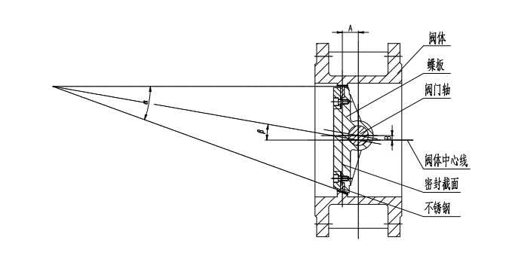
Figure 1 Triple Offset Metal-Seated Butterfly Valve
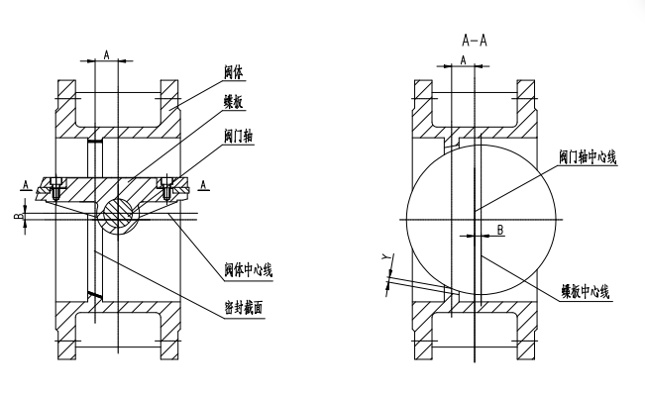Figure 2 Triple Offset Butterfly Valve -- Open State
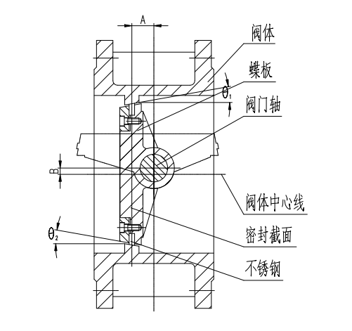
Figure 3 Triple Offset Butterfly Valve -- Closed State
6. Main Outline Dimensions, Connection Dimensions, and Weights -- See Figure 4
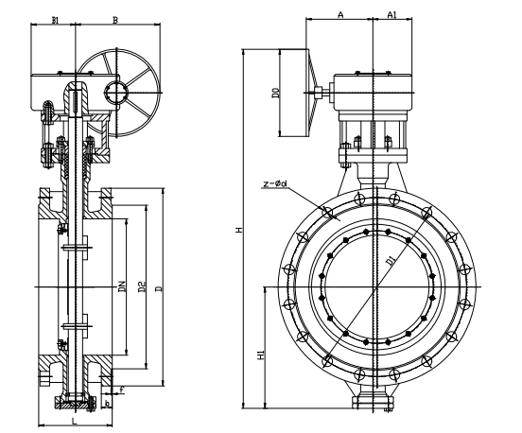
Figure 4 Flanged Triple Offset Metal-Seated Butterfly Valve Structural Outline Drawing
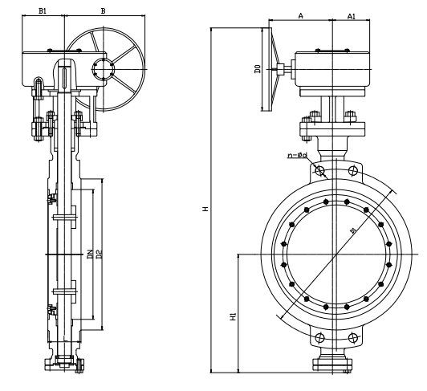
Figure 5 Wafer-Type Triple Offset Metal-Seated Butterfly Valve Structural Outline Drawing


WEIZIDOM GROUP
www.wsdvalves.com
South City, Longhu Town, Xinzheng City,
Zhengzhou City, Henan Province, China

